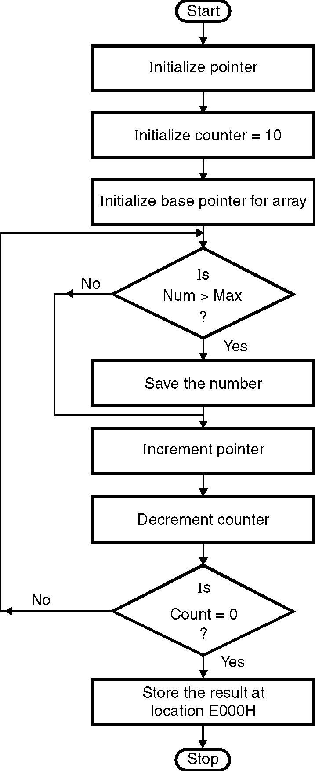
ØØ Explanation :
- For example : we have an array of 10 numbers. So we initialize the counter with 10. Also we initialize a pointer to point these numbers.
- Compare first number with initial maximum number i.e. zero. If number > maximum number, save number otherwise increment pointer to compare next number. Decrement counter, compare till all the numbers are compared. Store the maximum number in memory location E000 H.
ØØ Algorithm :
Step I : Initialize pointer.
Step II : Initialize counter.
Step III : Initialize maximum number =0
Step IV : Compare number with maximum.
If no carry i.e. if number is smaller don’t
interchange then goto step VI
Step V : Save the maximum number.
Step VI : Decrement counter.
Step VII : Increment pointer.
Step VIII : Check if count = 0. If not goto step IV.
Step IX : Store the maximum number.
Step X : Stop.
ØØ Flowchart : Refer flowchart 23.
ØØ Program :
Instruction Comment
LDA D000H
MOV C, A ; Initialize counter
XRA A ; Maximum = Minimum
; possible value = 0
LXI H, D001H ; Initialize pointer
BACK: CMP M ; Is number > maximum
JNC SKIP Flowchart 23
MOV A, M ; If number > maximum then
; interchange.
SKIP: INX H
DCR C
JNZ BACK
STA E000H ; Store maximum number
HLT ; Terminate program execution

